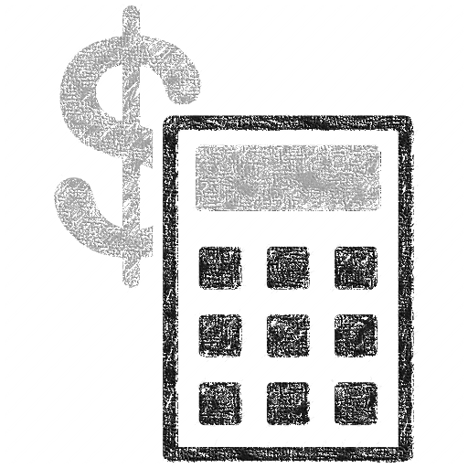

App proposal written by Chern Yee Chua, CSE 442 Fall 2015

Smart Balance Calculator

A smart tool to resolve YOUR DebT WITH YOUR FRIENDS

**So what is this?**

This is an app that is used to solve the debt issues with your friends intelligently. It will do the calculation for you so you don’t even need to take out calculator or work on excel. This app will do all this for you!

**My inspiration of creating this app**

The idea of this app is actually come from my own experience. Here’s the scenario:

Last summer, my friends and I together 6 of us went to EDC carnival for two days long. Since person A and Person F were the driver, so they paid for the gas for the entire journey and then we split the cost. Person B booked the Inn online for 6 of us. Person C bought the beers and Person D bought chicken wings for everyone in the carnival. Person B bought supper for everyone except Person C and D. After the event ended, we decided to go NYC for vacation. We met with another group of friends (3 of them) there. Person F who drove the car to NYC had to go back to Buffalo first because he had summer class at UB. So now we were a group of 8. Person B rented the whole apartment for few days and he paid for the whole amount. We went to China town for a walk, and it was bloody hot day. Person H had more cash so he paid for the drinks for those who wanted a drink. Later that day, two of the people in group did not want to go for broad-way show, so Person B bought the ticket for 7 of us. At night, we split into two groups and one of the group went to eat Korean food and the other group went for Japanese food. Person C was in first group and he paid for the Korean food while Person G paid for Japanese food. The next day, only Person B, E and H wanted to go for Empire State building, while Person A, C, and I wanted to go for Rockefeller site. Before we left NYC, we all had Malaysian food at Canal Street before we headed home. Forgot to mention that since Person F had already gone back, it was Person G driving Person H and Person I to NYC. So on the way home, person A’s car would have to take one more person and make it 4 person in each car.

So here’s the myth. Who is going to pay who for how much money at the end?

It seems like a complicated case to solve but if we can break all the events from the event of time, or someone has everything recorded in his/her legal yellow pad or smartphone, then we have made the whole procedure a step simpler. Let’s say this is what they have in their notes:

|  |  |
| --- | --- |
|  |  |
| Person A | Person B |
| 6/27 dinner at Korean (dan, iries, hector) $ 100 + tips | Lunch at Malaysian restaurant $200 |
| 6/27 refreshers (except henry) each $ 5 | Beers $40 |
| 6/28 ticket to broadway (except deb and sun) $70 |  |
| Gas to NYC (issac, deck, sonia) $40 |  |
| Gas to Buffalo (issac, deck, sonia, iries) $40 |  |

As you can see, everyone has different way of jotting down the list item. Like Person B’s note, it is unclear that when is that happened and how many people share the lunch and beer? What about we let a person to do a final debt list? If the person misses anything on the list, you can always file a claim. (At least that is what we did for the expenses…) Or we could just let those who help paying to ask from the persons who owed them directly. For whatever method is, it always requires extra steps to do calculations and sort. What I am going to say is, no matter how you handle with these sort of debt owing, chances are you will still be making mistakes because we as human, we are forgetful and careless sometimes.

With the help of this app, I am sure this kind of mistakes will never be happening again.

**Functions and Features**

Below shows the app design mock (not the finalized yet, just a simple sketch of the app structure and design).

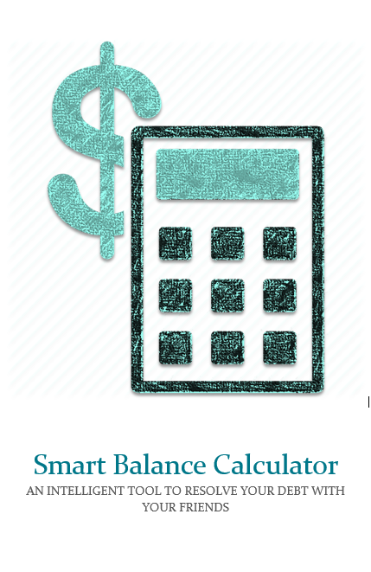

**Register your account using email address**

**1**

**2**

**Add your friends by using their email address**

**3**

**Start adding new balance statement!**

**3 simple steps**

**3**

Slide to the right

First time using this app will show a short tutorial on how to use it. More will be added later on.



**SMART BALANCE  
 CALCULATOR**

username or email address

password

**Sign in**

**Facebook login**

**Google+ login**

Forgot password?

**Register**

(EditText)

(Button)

Bring the user to registration page.

(Button)

Check if username and password matches. Proceed if true.

(Button)

(Button or dialog box)

Use facebook or google account to login.

Send the password recovery to the registed email address.

This is the login interface. User can either use their email address to sign in and register. They can choose to login via Facebook or Google too.



**Issac Chua**

**View statements**

**Add statement**

**Resolve statements**

**Current Balance:**

**$25.50**

Home

Account settings

Notification settings

Add new friend

Remove existing friend

Email invitation

Rate this app!

Contact us

Log out



**Issac Chua**

**View statements**

**Add statement**

**Resolve statements**

**Current Balance:**

**$25.50**

Or click this button

(2)

(1)

(4)

(3)

(6)

(5)

(8)

(7)

(9)

(13)

(10)

Slide to the right

(11)

(12)

This is the main interface of the app. Sliding right or clicking the button on the top left corner will bring out the side panel which will have a lot of options. We will discuss more below:

1. Home – Basically re-navigate to the main interface.
2. Add new friend – This allows you to add your friends into the group.
3. Remove existing friend – Remove a friend off your friend list. Noted: If there is an unsolved debt issue with that person, it will result in unresolved issue remaining in this app. The user icon will be changed to grey and the only way to solve this issue is to add the person back. Cases such as the user removing this app or the user logging out of the device will also result in the grey unresolved debt issue. (Tentative)
4. Account settings – Basically this allows you to choose your picture, change your name and password and etc.
5. Notification settings – You can set how the frequently the notification is delivered and also filter out some types of notification.
6. Email invitation – Basically this will just send invitation to other friends from your email address.
7. Rate this app – Probably will be a pop-up dialog box for the star rating or the link to Google Play.
8. Contact us – Contact the team and developer.
9. Log out – Log out of the device. Note: This will cause the unresolved debt issue if there is unresolved debt issue.
10. View Statements - Display all the statements from the beginning. (App design demo on following section)
11. Add statement – Add the bill statement (App design demo on following section)
12. Resolve statements – Display list of your friends and their debt status (money they owed or you owed, app design demo on following section)
13. Current Balance – It is just an indication of how much money people owed you or you owed people.

**NOTE: All of these are tentative and are subjected to change from time to time.**



**View statements**

**Clinton**

**Denise**

**$ 9.00**

**$ 9.00**

**9/2/2015 Grocery**

**Nguyen**

**Denise**

**$ 5.00**

**$ 5.00**

**8/31/2015 Movie Ticket**

**Yang**

**$ 15.00**

**9/1/2015 Lunch at Thai**

**Tommy**

**$ 13.00**

**Clinton**

**$ 12.00**

**Yuen**

**$ 12.00**

**8/31/2015 Burger King**

**Tommy**

**$ 12.00**

**Nguyen**

**$ 35.00**

**$ 35.00**

**Denise**

**$ 35.00**

**8/30/2015 Darien Lake**

**Chris**

**Racheal**

**Dendi**

**$ 35.00**

**$ 35.00**

**RESOLVED!**

**RESOLVED!**

(ListView)

This is from (10). It shows a list of statements sorting by the time of event. Noted that cases that are resolved are marked “RESOLVED” and are in grey color. The design mock is just a sketch of idea, it will most likely be changed.



**Add statement**

Enter description



**Paid by:**

**Issac**

**Mode:**

**split**

**Total Amount: $**

0.00

**Member:**

**Date:**

**9/2/2015**

**Deadline:**

**7 days**

**CONFIRM!**

A notification has sent to all the members!

**Snapshot:**

**Click to add**

**Click to add**



**Add statement**

Enter description



**Paid by:**

**Issac**

**Mode:**

**split**

**Total Amount: $**

0.00

**Member:**

**Date:**

**9/2/2015**

**Deadline:**

**7 days**

**CONFIRM!**

**Snapshot:**

**Click to add**

**Click to add**

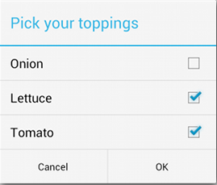

**Member**

**Joshua**

**Clinton**

**Denise**

Both snapshots are from (11).

(Snapshot on the left) shows the possible options while recording the bill. First line is an EditText box which allows you to write the description of the event, such as “Dining at ABC”, “Movie night with besties”, and etc. As you can see on the next line you can select any type of event or select the last button for more other options.

Next, you insert the total amount, and you can select who is paying for that expense. Select the mode – split equally, by percent, and individual (drag the scroll bar for specific amount).

And then, you can select the date and deadline. The deadline is set so that the debt payment can be made in within the timeframe. This app will push annoying notification when the deadline is met, and things like that.

(Snapshot on the right) will be shown when the user clicks “Click to add”. You just need to pick those friends who were in that event to split the check. There is also a snapshot function which allows you to take a picture of the receipt as the proof of expense.



**Add statement**

Grocery



**Paid by:**

**Issac**

**Mode:**

**split**

**Total Amount: $**

27.00

**Member:**

**Date:**

**9/2/2015**

**Deadline:**

**7 days**

**Snapshot:**

**Click to add**

**Click to add**

**Clinton**

**$ 9.00**

**Denise**

**$ 9.00**



Lastly, click “Confirm” to continue. A push notification will be sent to each participant to make sure that there exists such expense. They just simply check “Accept” or “Decline” of that expense.

(Snapshot on the left) This is the view of “Add statement” after the user has filled in the member and snapshot section.

(Spinner)

(Date picker)

(Spinner)

(Dialog box)

(ListView)

(Dialog box)

(ImageView)



**Resolve statements**



**You owed Clinton: $ 50.20  
Clinton owed you: $23.20  
Total balance: - $30.00**

**Resolved?**

**You owed Denise: $ 0.00  
Denise owed you: $49.00  
Total balance: $49.00**

**Resolved?**

**You owed Joshua: $ 0.00  
Joshua owed you: $0.00  
Total balance: $0.00**

**Resolved!**

(Snapshot on the right) is from (12). It displays a list of your friends’ status – whether you owe your friend or your friend owes you. If the debt is not resolved, the button will be in grey color. If the debt is resolved, the button will turn to green color (see the last item on the list). The app will also send notification to the party members that the debt is resolved. (Again, those notification can be turned off)

Note: The resolved action cannot be undone. Make sure the payment is clear before checking the resolved button!

I am thinking to include a third paypal paying sytem using Braintree API in the future. But up to this point, all sort of transaction are done by the users themselves for security reasons.